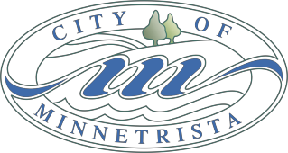

CITY COUNCIL WORK SESSION MEETING AGENDA
July 17, 2017
5:30 – 6:30pm

- Call to Order
- Minnetrista Five-year HR Planning
- 2017-2018 Minnetrista Strategic Plan Update
- Adjourn

