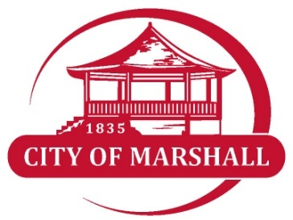

APPLICATION- OUTDOOR CAFE

PART ONE | APPLICANT INFORMATION:
NOTE: If applicant is not the Owner, a Letter of Authorization from the Owner must be attached

Primary Contact: ____________________________________________________________________

Registered Owner(s)_________________________________________________________________

Address ____________________________________________________________________________

Telephone Number __________________________ Email: ____________________________

Website: ______________________________________

PART TWO | ABOUT THE PROPERTY

Name of Business: ________________________________________________________

Name of Contact at Business:___________________________________________________________________

Street Address: _______________________________________________________________________

Business Hours: ____________________________________________________________________

Outdoor Cafe
Application is for our outdoor dining, a permit for outside dining on public sidewalk. In making this application, the applicant represents all of the above statements and any attached maps and drawings to be a true and accurate description of the proposed dining area. The applicant agrees that the permit, if granted, is issued on the representation made herein and that any permit issued may be revoked without notice on any breach of representation or conditions. It is understood that any permit issued on this application will not grant right of privilege to erect any structure or to use any premises described for any purpose or in any manner prohibited by the City’s ordinances. It is also understood that no permanent structure or fixture is to be constructed, attached or erected upon any public sidewalk.
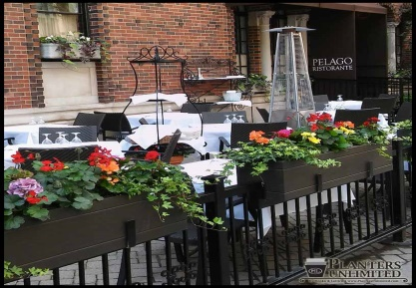
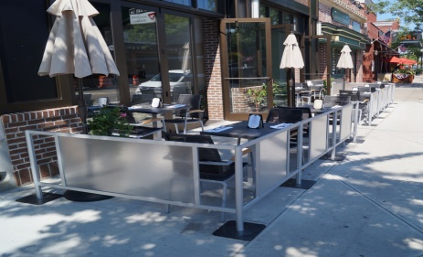

Rules and conditions for approval:
- Realty taxes, service fees and utilities paid to the City of Marshall must be paid current on all properties owned by the applicant at the time of the application.
- Each restaurant location will be reviewed and permitted individually.
- Outside dining permit expired December 31 of each year and must be renewed annually.
- Business must submit documentation showing the City of Marshall listed as Additional Insured.
- Business must submit documentation showing minimum coverage of one million dollars ($1,000,000.00) for general liability insurance.
- Restaurant will be responsible for cleaning and maintenance of any eating area.
- Outdoor seating area can operate between the hours of 6:00am and 11:00pm.
- All maintenance and upkeep of the public right-of-way associated with the operation of the business is the responsibility of the owner.
- The outdoor café shall leave no less than five feet clear of all obstructions (i.e. street lighting, benches, trees, trash receptacles, etc.)
- All tables, chairs and other appurtenances shall be constructed in such a manner that they can be easily, and shall be, removed each night and shall be removed during winter months and at other times required by the city.
- The operation shall only be permitted incidental to the operation of the restaurant with on-site food preparation on private contagious property and only along the frontage of said restaurant where that restaurant has a zero front setback form the public walk.
- Violation of any of the above rules and guideless will be grounds for immediate revocation of permit.
- No permit will be issued until the applicant enters into a license agreement for the use of the right-of-way with the City of Marshall.
- Outdoor furnishings materials and colors should be selected for continuous harmony and aesthetic quality with the adjoining buildings and streetscapes. Materials shall be of durable quality such as wrought iron; light gauge materials like aluminum and plastics shall be general discouraged. Weather resistance wood is allowed only as a secondary accent material.
- Colors should be harmonious, brilliant or bright colors shall be used only for accent.
- Tables to be placed within the city’s right-of-ways shall not have a surface area greater than eight (8) square feet, be easily removable and in no way impede safe pedestrian movement.
- Devices incorporate to separate eating areas from pedestrian pathways such as fencing or planters, must conform to above standards of design and shall be installed as directed by the City of Marshall.
- Signed approval of the application must be obtained from the Economic Development Committee PRIOR to the beginning of the project.
- Loud music is prohibited
- The sale and consumption of alcoholic beverages shall be strictly prohibited.
- According to State of Illinois law, it requires "no-smoking" signs and bans smoking within 15 feet (4.6 m) of openings of a building.

APPLICATION CHECKLIST:
□ Application
□ Plan/Drawing submitted
□ Copy of insurance with City of Marshall as additional insured
□ Signed a hold harmless agreement
□ Signed license agreement for the use of the Right-of-way
□ Copy of insurance ($1,000,000.00 minimum)
□ $15 application fee submitted (non-refundable)

DRAWING | Sketch plan, be sure to include the following information:

You may deliver your application in person or send it by mail to:
The City of Marshall
C/O Economic Development
201 S. Michigan Avenue| P.O. Box 298 | Marshall, IL 62441
If you have any questions regarding the Program, please contact Economic Development at 217-826-8087.
FAILURE TO COMPLETE THIS ENTIRE APPLICATION MAY RESULT IN DELAYS IN PROCESSING.

Building Owner Signature ________________________________________

Approved? ______________

Economic Development Signature____________________________________ Date ________________

Zoning Officer Signature____________________________________ Date ________________

