CITY OF BENTON
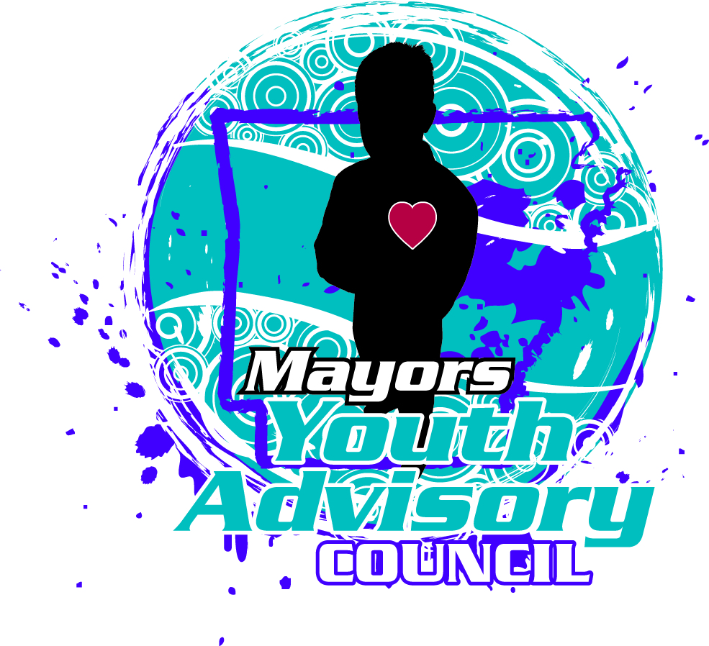
MAYOR’S YOUTH ADVISORY COUNCIL RE-APPLICATION
*Please return completed application no later than Monday, April 17, 2017 to any of these locations:
Benton High School Counselors’ Office or City of Benton Mayor’s Office

Name: _________________________________________________ Cell Phone #: _________________________
E-Mail Address: __________________________________________________________________________________
School attending in 2017-18: _____________________ Grade you will be in for 2017-18: __________
- Do you feel that you have served faithfully as a member of the MYAC and at the volunteer projects where you volunteered?

- If you feel you were unable to serve faithfully; what changes are you willing to make to be more involved in the 2017-18 MYAC?

- List your planned obligations, interests and activities for the 2017-18 year (job, hobbies, organizations, clubs, sports, positions held.)

- Can you attend 2 meetings monthly on the 1st & 3rd Mondays each month at 5:30 pm? ____________
- Do you have the time and the desire to serve on volunteer community projects approximately 2-4 hours a month throughout the 2017-18 year? ______________

- I understand that if I am selected as a member of the City of Benton Mayor’s Youth Advisory Council, I will need to attend the regularly scheduled monthly meetings and participate in a manner that brings honor and respect to the City of Benton, its citizens and this Council.
Member Signature: ________________________________________ Date: _______________________
- I give my permission for __________________________ to re-apply for the MYAC for the City of Benton. If selected I will support him/her in attending meetings, participating in community service projects and all functions related to the MYAC.
______________________________________ _____________________
Signature of Parent or Guardian Date

