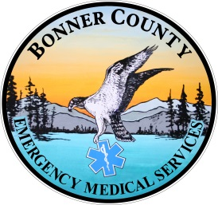 **Burns, Rule of NINES**

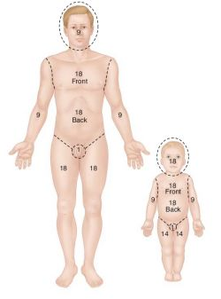The rule of nines assesses the percentage of burn and is used to help guide treatment decisions including fluid [resuscitation](http://www.emedicinehealth.com/script/main/art.asp?articlekey=21780) and becomes part of the guidelines to determine transfer to a burn unit. To approximate the percentage of burned surface area, the body has been divided into eleven sections:

* Head
* Right arm
* Left arm
* Chest
* Abdomen
* Upper back
* Lower back
* Right thigh
* Left thigh
* Right leg (below the knee)
* Left leg (below the knee)

Each of these sections takes about nine percent of the body's skin to cover it. Added all together, these sections account for 99 percent. The genitals make up the last one percent.

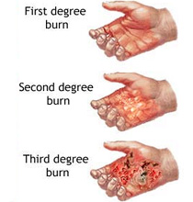To apply the rule of nines, add up all the areas of the body that are burned deep enough to cause blisters or worse (2nd or 3rd degree burns).

This means a superficial burn. The surface of the skin is damaged, but the epidermis (the outermost [layer of skin](http://firstaid.about.com/od/softtissueinjuries/a/07_skin_layers.htm)) is still intact, and therefore able to perform its functions (control temperature and protect from infection or injury).

This means damage that has extended through the epidermis and into the dermis (the second [layer of skin](http://firstaid.about.com/od/softtissueinjuries/a/07_skin_layers.htm)). Second-degree burns also are known as partial-thickness burns.

This indicates the burn has destroyed both the epidermis and dermis. The victim has the same trouble with fluid loss, heat loss, and infection that come with second-degree burns.