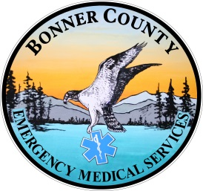**prehospital stroke scale**

**Cincinnati Stroke Scale**

|  |
| --- |
| Stroke Recognition Tool **(FAST)** |
| **Facial Droop:** Have patient show teeth or smile.   * Normal- both sides of face move normally * Abnormal- one side of face does not move as well as the other side |
| **Arm Drift:** Patient closes eyes and extends both arms straight out, with palms up for 10 seconds.   * Normal- both arms move the same, or both arms do not move * Abnormal- one arm doesn’t move or one arm drifts down compared with the other |
| **Speech:** Have patient say “you can’t teach a dog new tricks”   * Normal- patient uses correct words with no slurring * Abnormal- patient slurs words, uses the wrong words, or is unable to speak |
| **Time:** Time is crucial to good outcomes. Be sure to note time of onset of symptoms  ***Interpretation: If any one of these three signs is abnormal, the probability of stroke is 72%.*** |

**Cincinnati Stroke Scale (FAST) Normal**

**F**acial Droop (ask patient to smile or show their teeth) Both sides should move equal

**A**rm Drift (ask patient to close eyes and hold both arms out palm up) Both arms move the same

**S**peech (ask patient to say “The sky is blue in Cincinnati”) Patient uses correct words no slurring

**T**ime is crucial About 3 hours before treatment won’t help

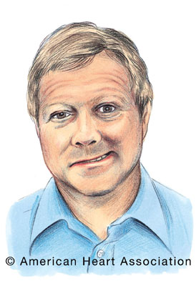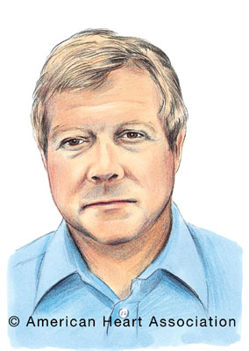

**Facial DROOP**

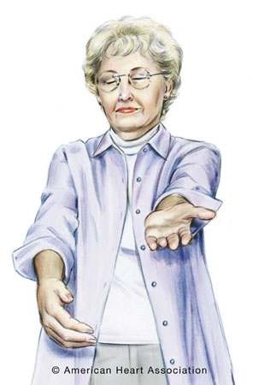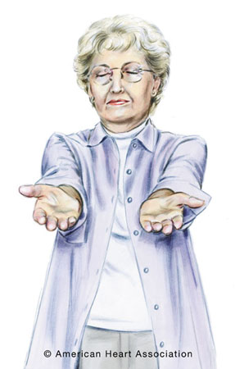

**ARM DRIFT**