Taser® Probe Removal

Clinical Indications and Contraindications
- Clinical Indications:
Patient with uncomplicated conducted electrical weapon (Taser®) probes embedded subcutaneously in non-sensitive areas of skin.
Taser probes are barbed metal projectiles that may embed themselves up to 13 mm into the skin.
- Contraindications:
Patient with conducted electrical weapon (Taser®) probe penetration in vulnerable areas of the body should be transported for further evaluation and probe removal: This includes probes embedded in skin above the level of clavicles, female breasts, or genitalia.
Suspicion that probe might be embedded in bone, blood vessel, or other sensitive structures.

PROCEDURE GUIDELINES
R- EMR | E – EMT | A-AEMT | P-PARAMEDIC | **M-Medical Control **
***Higher level providers are responsible for lower level treatments***
- Ensure wires are disconnected from weapon.  - Stabilize skin around probe using non-dominant hand.  - Grasp probe by metal body using dominant hand.  - Remove probe in single quick motion.  - Wipe wound with antiseptic wipe and apply dressing. | P²⁻⁴

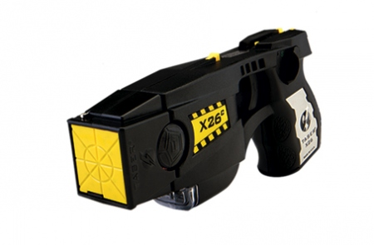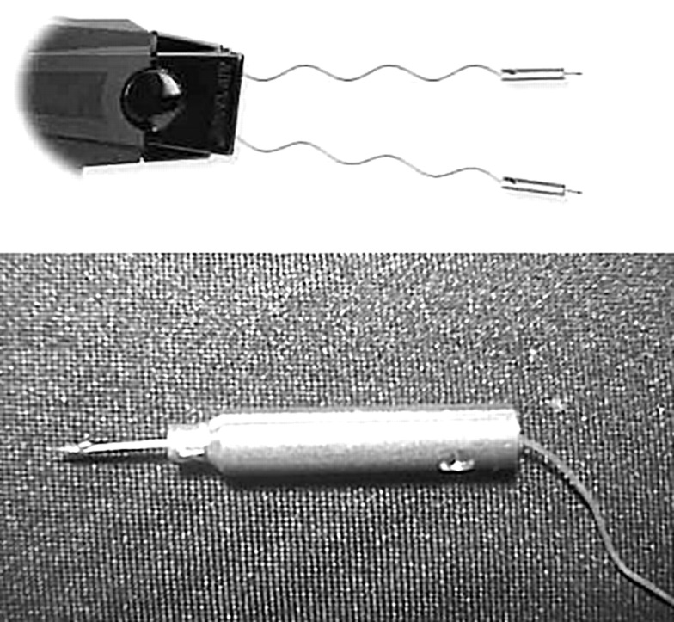

^{2,}EMT, ³AEMT, and ⁴Paramedic providers may perform these procedures if credentialed with the appropriate OM.

