Spinal Immobilization
Clinical Indications
- Patient has been determined to have significant risk of C- Spine injury
- Determine if available equipment will work for the patient

PROCEDURE GUIDELINES
R- EMR | E – EMT BASIC | A-EMTA | P-PARAMEDIC | **M-Medical Control **
***Higher level providers are responsible for lower level treatments***
- Explain the procedure to the patient.  - Place the patient in an appropriately sized C-collar while maintaining in-line stabilization of the C-spine. This stabilization, to be provided by a second provider, should not involve traction or tension but rather simply maintaining the head in a neutral, midline position while the first provider applies the collar.  - Once the collar is secure, the second provider should still maintain their position to ensure stabilization (the collar is helpful but will not do the job by itself.)  - Place the patient on a long spine board with the log-roll technique if the patient is supine or prone. For the patient in a vehicle or otherwise unable to be placed prone or supine, place them on a backboard by the safest method available that allows maintenance of in-line spinal stability. Stabilize the patient with supportive soft blocks, straps or other similar devices. Once the head is secured to the backboard, the second provider may release manual in-line stabilization.  - NOTE: Some patients, due to size or age, will not be able to be immobilized through in-line stabilization with standard backboards and C-collars. Never force a patient into a non-neutral position to immobilize them. Such situations may require a second provider to maintain manual stabilization throughout transport to the receiving facility.  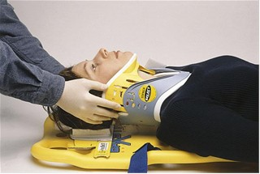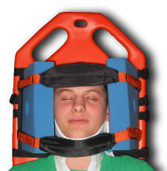 | E¹
¹EMR providers may perform these procedures if credentialed with the appropriate OM.
A combination of a rigid cervical collar and supportive blocks on a backboard with straps is very effective in limiting motion of the cervical spine and is recommended. Soft blocks should be the last piece of stabilization equipment applied. Patients that are combative, particularly young children, may be at greater risk for further injury by forced immobilization until properly sedated or more calm.

