Splinting
Clinical Indications
- Immobilization of an extremity for transport, either due to suspected fracture, sprain, or injury.

PROCEDURE GUIDELINES
R- EMR | E – EMT BASIC | A-EMTA | P-PARAMEDIC | **M-Medical Control **
***Higher level providers are responsible for lower level treatments***
- Assess and document pulses, sensation, and motor function prior to placement of the splint. If no pulses are present and a fracture is suspected, consider reduction of the fracture prior to splinting.  - Remove all clothing from the extremity.  - Select a site to secure the splint both proximal and distal to the area of suspected injury, or the area where the splint will be placed. Do not secure the splint directly over the injury.  - Place the splint and secure with Velcro, straps, or bandage material (i.e. Kling, Kerlex, cloth bandage, etc.) depending on the splint manufacturer and design.  - Document pulses, sensation, and motor function after placement of the splint. If there has been any deterioration in any of these parameters, remove the splint and reassess.  - If a femur fracture is suspected and there is no evidence of pelvic fracture or instability, the following procedures may be followed for placement of a femoral traction splint (Traction splinting is not an EMR procedure): 1) Assess neurovascular function. 2) Place the ankle device over the ankle. 3) Place the proximal end of the traction splint on the posterior side of the affected extremity, being careful to avoid placing too much pressure on genitalia or open wounds. Make certain the splint extends proximal to the suspected fracture. If the splint will not extend in such a manner, reassess possible involvement of the pelvis. 4) Extend the distal end of the splint at least 6 inches beyond the foot. 5) Attach the ankle device to the traction crank. 6) Twist until moderate resistance is met. 7) Reassess alignment, pulses, sensation, and motor function. If there has been deterioration, release traction and reassess.  - Document the time, type of splint, and the pre and post assessment of pulse, sensation, and motor function in the patient care report (PCR).  - NOTE: Some patients, due to size or age, will not be able to be immobilized through in-line stabilization with standard backboards and C-collars. Never force a patient into a non-neutral position to immobilize them. Such situations may require a second provider to maintain manual stabilization throughout transport to the receiving facility. | E¹
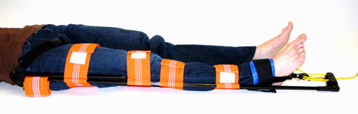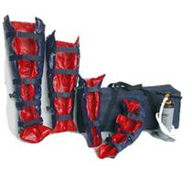
Traction splint vacuum splints for extremities
¹EMR providers may perform these procedures (excluding traction splint placement) if credentialed with the appropriate OM.

