chest decompression

Clinical Indications
- Patients with hypotension (SBP < 90 mmHg), clinical signs of shock, and at least one of the following signs:
Jugular venous distention.
Tracheal deviation away from the side of the injury (often a late sign).
Absent or decreased breath sounds on the affected side.
Hyper-resonance to percussion on the affected side.
Increased resistance when ventilating a patient.
- Patients in traumatic arrest with chest or abdominal trauma for whom resuscitation is indicated. These patients may require bilateral chest decompression even in the absence of the signs noted above.

TREATMENT GUIDELINES
R-EMR | E–EMT | A-AEMT | P-PARAMEDIC | **M-Medical Control **
***Higher level providers are responsible for lower level treatments***
- Don personal protective equipment (gloves, eye protection, etc.).  - Administer high flow Oxygen.  - Identify and prep the site: Locate the second intercostal space in the mid-clavicular line on the same side as the pneumothorax. If unable to place anteriorly, lateral placement may be used at the fourth ICS in the mid-axillary line.  Prepare the site with povidone-iodine ointment or solution.  - Insert the catheter (14 gauge for adults) into the skin over the third rib and direct it just over the top of the rib (superior border) into the interspace.  - Advance the catheter through the parietal pleura until a “pop” is felt, and air or blood exits under pressure through the catheter, then advance the catheter only to chest wall.  - Remove the needle, leaving the plastic catheter in place.  - Secure the catheter hub to the chest wall with dressings and tape.  - Attach a Heimlich valve to the catheter to provide an out let for air without allowing new air to be introduced, and secure.  - Document procedure, result and needle placement location in PCR.  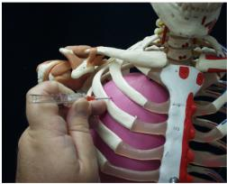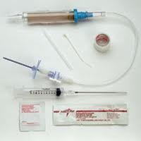 | P
QA Parameters: 100% of patients receiving needle Chest Decompression.

