Pelvic Sling

Clinical Indications
- Immobilization of the pelvis for transport, due to suspected pelvic fracture. Patients with a history of high energy, multi‐system trauma i.e.: motor vehicle accidents, pedestrian accidents, crush injuries, and falls are at greater risk.
- Unrestrained movement of fractured pelvic bones following significant trauma can cause internal hemorrhage and death. Any motion between the torso and legs can cause severe shifting of the fractured pelvis, potentially dislodging any clotting already in place.
- MAST pants can stabilize a broken pelvis, but over or under inflation of MAST will compromise their effectiveness. There is no way to know when the pressure is right for pelvic stabilization.
- The Pelvic Sling was designed to apply the ideal amount of force to bring the pelvic ring back into alignment. Like the MAST, the Pelvic Sling uses circumferential pressure to squeeze the pelvis uniformly. The Sling’s major advantage is that its buckle has a definite stop with a positive click at exactly the optimal calculated pressure.

PROCEDURE GUIDELINES
R- EMR | E – EMT BASIC | A-EMTA | P-PARAMEDIC | **M-Medical Control **
***Higher level providers are responsible for lower level treatments***
- Clothing should be removed before placing the Sling. (It is designed to stay in place until the patient goes to surgery).  - Three sizes are available to fit patients  Large (>200 pounds)  Standard (110 – 200 pounds): The standard size can be field modified to fit smaller patients, just cut off the plastic slide pad and use the Velcro that is under it.  Small (80-120 pounds)  - The Sling wraps the hips and buttocks, not the waist. Be sure you place the top of the sling no higher than the anterior superior spine of the femur. Try to make sure the buckle is centered over the alignment of the pubic symphasis.  - The Sling is a single‐use, disposable item.  - Once the sling is in place, don’t remove it.^{2,3,4} | E²⁻⁴
Pelvic sling placement is contraindicated for patients under 80 pounds.
Like a C-collar, the Pelvic Sling should be applied to any patient with high speed or other significant trauma suspicious for pelvic injury.
Even if instability of the pelvis is not obvious on exam, mechanism of injury alone may indicate use of the Sling.
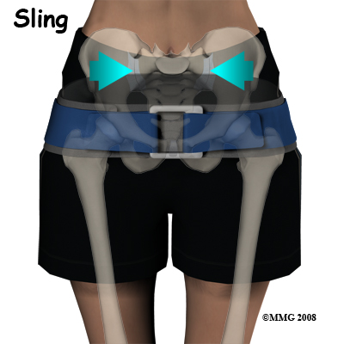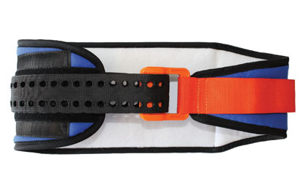
²EMT, ³AEMT and ⁴EMT-P providers may perform these procedures if credentialed with the appropriate OM.

