GASTRIC TUBE INSERTIOIN

Clinical Indications
- Gastric decompression in intubated patients or for administration of activated charcoal in patients with altered mental status.

PROCEDURE GUIDELINES
R- EMR | E-EMT | A-EMTA | P-PARAMEDIC | **M-Medical Control **
***Higher level providers are responsible for lower level treatments***
- Estimate insertion length by superimposing the tube over the body from the nose to the stomach.  - Flex the neck if not contraindicated to facilitate esophageal passage.  - Liberally lubricate the distal end of the tube (water-soluble lubricant, preferably 2% Xylocaine jelly) and pass through patient’s nostril along the floor of the nasal passage. Do not orient the tip upward into the turbinates. This increases the difficulty of the insertion and may cause bleeding.  - In the setting of an unconscious, intubated patient or a patient with facial trauma, oral insertion of the tube may be considered or preferred.  - Continue to advance the tube gently until the appropriate distance is reached.  - Confirm placement by injecting 20 cc of air and auscultate for the swish or bubbling of the air over the stomach. Additionally, aspirate gastric contents to confirm proper placement.  - Secure the tube.  - Decompress the stomach of air and food either by connecting the tube to suction or manually aspirating with the large catheter tip syringe.  - Document the procedure, time, and result on the patient care report (PCR).  - Equipment needed:  Personal protective equipment Adhesive tape  NG/OG tube Suction device  Catheter tip irrigation 60ml syringe Drainage bag  Water-soluble lubricant, preferably 2% Xylocaine jelly Stethoscope  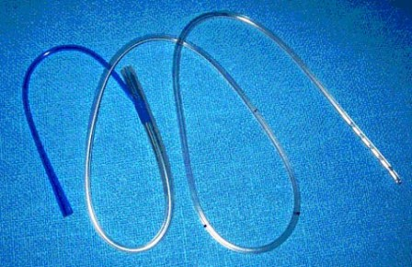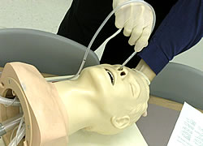 | P
Nasogastric tubes are contraindicated in the presence of severe facial trauma, due to the possibility of inserting the tube intracranially. In this instance, an orogastric tube may be inserted.
The main complications of NG tube insertion include aspiration and tissue trauma. Placement of the catheter can induce gagging or vomiting; therefore suction should always be ready to use in that case.

