Temperature measurement
Clinical Indications
- Suspected infection, hypothermia, hyperthermia
- Cold or mottled skin; warm or hot skin temperature
- Evidence for sepsis
- Recent cardiac arrest; may be helpful in post resuscitation assessment

PROCEDURE GUIDELINES
R- EMR | E - EMT | AEMT | P-PARAMEDIC | **M-Medical Control **
***Higher level providers are responsible for lower level treatments***
- Adult patients: If conscious cooperative and in no respiratory distress, an oral temperature is preferred. For infants or adults that do not meet the criteria above, a rectal temperature is preferred.  - ORAL TEMPERATURE: To obtain an oral temperature, ensure the patient has no significant oral trauma and place the thermometer under the patient’s tongue with appropriate sterile covering.  - Have the patient seal their mouth closed around the thermometer.  - If using the electric thermometer, leave the device in place until there is indication that an accurate temperature has been recorded (per the “beep” or other indicator specific to that device. If using a traditional thermometer, leave it in place until there is no change in the reading for at least 30 seconds (usually 2-3 minutes)  - Record time, temperature, method and scale (C° or F°) in PCR.  - RECTAL TEMPERATURE: Prior to obtaining a rectal temperature, cover the thermometer with an appropriate sterile cover, apply lubricant, and insert into rectum no more than 1-2 cm beyond the external anal sphincter.  - If using the electric thermometer, leave the device in place until there is indication that an accurate temperature has been recorded (per the “beep” or other indicator specific to that device. If using a traditional thermometer, leave it in place until there is no change in the reading for at least 30 seconds ( usually 2-3 minutes)  - Record time, temperature, method and scale (C° or F°) in PCR.  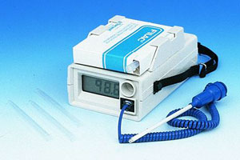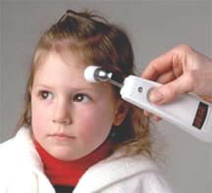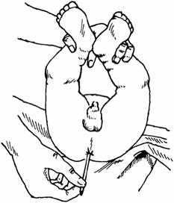 | E
A rectal or ear (tympanic membrane) temperature reading is 0.5 to 1°F (0.3 to 0.6°C) higher than an oral temperature reading. A temperature taken in the armpit is 0.5 to 1°F (0.3 to 0.6°C) lower than an oral temperature reading.
In most adults, an oral temperature above 100F or a rectal or ear temperature above 101F is considered a fever. A child has a fever when his or her rectal temperature is 100.4F or higher.

