automated Defibrillation (AED)
Clinical Indications
- Automated defibrillation for unconscious patients in cardiac arrest
- Pulseless, Not breathing
- Pulseless patient requires unsynchronized defibrillation
- Patients with a pulse and an organized rhythm can receive synchronized Cardioversion.

PROCEDURE GUIDELINES
R-EMR- | E – EMT BASIC | A-EMTA | P-PARAMEDIC | **M-Medical Control **
***Higher level providers are responsible for lower level treatments***
- Assess patient, monitor cardiac status and determine cardiac arrest.  - If multiple rescuers are available, one rescuer should provide uninterrupted CPR (9031) while the AED is being prepared for use.  - Apply defibrillator pads per manufacturer recommendations. Use alternate placement when implanted devices (pacemakers, AICDs) occupy preferred pad positions.  - Remove any medication patches on the chest and wipe off any residue.  - If necessary, connect defibrillator leads: white to the anterior chest and the red to the posterior pad. Activate AED for analysis of rhythm. Stop CPR and clear the patient for rhythm analysis. Keep interruption in CPR as brief as possible.  - Defibrillate if appropriate by depressing the “shock” button. Assertively state “CLEAR” and visualize that no one, including yourself, is in contact with the patient prior to defibrillation.  - Begin CPR (chest compressions and ventilations) immediately after the delivery of the defibrillation.  - After two minutes of CPR, analyze rhythm and defibrillate if indicated. Repeat every 2 minutes. If “no shock advised” appears, perform CPR for two minutes and reanalyze.  - Transport and continue treatment as indicated.  - Note procedural details, response and time in patient care report (PCR).  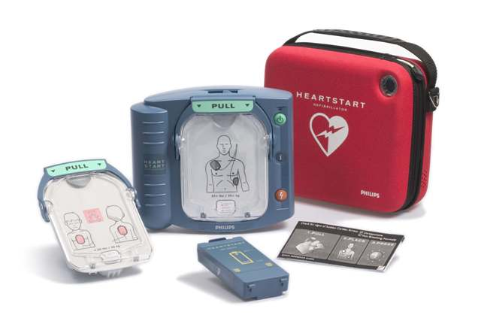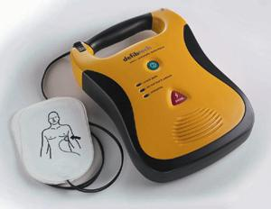 | R
- ** Consider discussion with Medical Control if defibrillation is unsuccessful after 2 attempts** | M
Pearls:
Keep interruptions of CPR as brief as possible. Adequate CPR is key to successful resuscitation.
Age less than 8 years: use pediatric pads.

