12 lead EKG

Clinical Indications
- Suspected cardiac patient
- Suspected tricyclic overdose
- Electrical injuries
- Syncope
- Suspected hyperkalemia

PROCEDURE GUIDELINES
R-EMR | E – EMT | A-AEMT | P-PARAMEDIC | **M-Medical Control **
***Higher level providers are responsible for lower level treatments***
- If patient is unstable, definitive treatment is the priority. If patient is stable, perform 12-lead EKG.  - Prepare EKG monitor and connect patient cable with electrodes.  - Enter the required patient information (age, etc) into the 12-lead device.  - Expose chest and prep as necessary. Modesty of the patient should be respected.  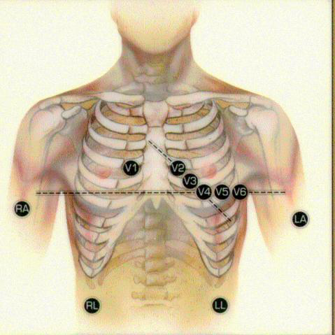  - Apply leads using the following landmarks:  RA- right arm, LA- left arm, RL- right leg, LL- left leg  V1- 4th intercostal space (ICS) at right sternal border  V2- 4th ICS at left sternal border  V3- Directly between V2 and V4  V4- 5th ICS at midclavicular line  V5- Level with V4 at left anterior axillary line  V6- Level with V5 at left midaxillary line  Instruct patient to remain still, and acquire EKG  Transmit EKG to medical control if transmission is possible.  - Continue with EKG monitoring if appropriate.  - Evaluate for rate, rhythm and signs of acute ischemia.  - Document the procedure, time and results on the patient care report (PCR).  Attach a copy of the 12-lead EKG to the PCR. | P^{2,3}
- ** Discuss EKG interpretation with Medical Control if MI is suspected ** | M
2,3EMT and AEMT providers may perform these procedures if credentialed with the appropriate OM.

