oral tracheal intubation
Clinical Indications
- Inability to adequately ventilate a patient with a bag-valve-mask, or longer transport distances requiring a more advanced airway.
- An unconscious patient without a gag reflex who is apneic or is demonstrating inadequate respiratory effort.
- A component of Medication Assisted Intubation.

_{PROCEDURE GUIDELINES}
_{R- EMR} | _{E – EMT} | _{A-AEMT} | _{P-PARAMEDIC} | _{**M-Medical Control **}
***Higher level providers are responsible for lower level treatments***
- Preoxygenate and hyperventilate the patient with 100% oxygen (9006). Monitor Pulse Oximetry (9001) throughout and following procedure.  - Select the appropriate ET tube and stylet for the patient. Have suction available.  - Lubricate the tube.  - Using laryngoscope, visualize vocal cords. Use Sellick’s Maneuver/ BURP (Backward, Upward, and Rightward Pressure on the larynx to assist you).  - Limit each intubation attempt to 30 seconds with BVM between attempts.  - Visualize tube passing through vocal cords.  - Confirm and document tube placement using an end-tidal CO₂ monitoring. Inflate the cuff with 3-10 cc of air; secure the tube to the patient’s face.  - Auscultate for bilaterally equal breath sounds and absence of sounds over the epigastrium. If you are unsure of placement, remove tube and ventilate patient with Bag-Valve-Mask.  - Consider using a Blind Insertion Airway Device such as the King Airway (9007), if oral tracheal intubation attempts are unsuccessful.  - Monitor continuously with Pulse Oximetry (9001), and Capnography (ALS procedure-9002) when available.  - Document ETT size, time, result, and placement location by the centimeter marks either at the patient’s teeth or lips on the patient care report (PCR).  - Consider placing an NG or OG tube to clear stomach contents after the airway is secured with an ET tube.  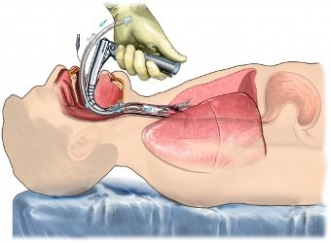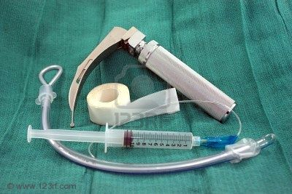 | P

