NITROUS OXIDE ANALGESIA

Clinical Indications
- Prehospital analgesia for indications including chest pain, myocardial infarction, kidney stones, urinary retention, burns, fractures, dislocations and labor pain.
- Nitrous Oxide is contraindicated in the presence of altered metal status, intoxication, facial burns, facial trauma, chest trauma including pneumothorax, undiagnosed abdominal pain, respiratory distress, congestive heart failure, pulmonary hypertension, eye surgery, decompression sickness, B12 deficiency, head trauma and the first two trimesters of pregnancy.

PROCEDURE GUIDELINES
R- EMR | E – EMT | A-AEMT | P-PARAMEDIC | **M-Medical Control **
***Higher level providers are responsible for lower level treatments***
- Gather the necessary equipment.
- The concentration of nitrous oxide-oxygen mixture is fixed at 50:50. No other mixture is
permitted.
- Nitrous oxide-oxygen is self-administered by the patient with EMT assistance. The
negative pressure exerted by the patient’s inhalation effort triggers gas flow. A tight
mask-face seal is necessary.
- Cylinders must be positioned and secured in the upright position.
- Cylinders must be stored at a temperature greater than 10 degree Celsius at all times.
- Cylinders must not be stored outdoors or in vehicles that are not maintained at a
temperature of at least 10 degrees Celsius at all times
- Cylinders must not be stored in outside compartments of vehicles
- Pressure readings should be checked and documented at the beginning of each shift
and after each use.
- Turn the cylinder end over end three times immediately prior to each use. This will ensure
proper gas mixing.
- Document the treatment, route and effect on the patient care report (PCR).
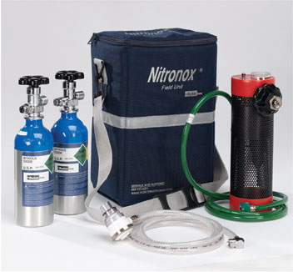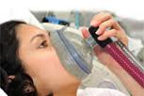

Inhaled Nitrous Oxide treatment is to be avoided during ambulance transport due to risk of provider exposure.

