TrANSPORT VENTILATOR oPERATION

Clinical Indications
- Management of the ventilator of a patient during a prolonged or interfacility transport of an intubated patient.

PROCEDURE GUIDELINES
R- EMR | E – EMT | A-AEMT | P-PARAMEDIC | **M-Medical Control **
***Higher level providers are responsible for lower level treatments***
- Transporting personnel should review the operation of the transport ventilator with the treating personnel (physician, nurse or respiratory therapist) in the referring facility prior to transport.  - All ventilator settings including respiratory rate, FiO₂, mode of ventilation, and tidal volumes should be recorded prior to initiating transport. Additionally, the recent trends in oxygen saturation experienced by the patient should be noted.  - Prior to transport, specific orders regarding any anticipated changes to ventilator settings as well as causes for significant alarm should be reviewed with the referring medical personnel.  - Once in the transporting unit, confirm adequate oxygen delivery to the ventilator.  - Frequently assess the patient’s breath sounds and respiratory status to assess for possible tube dislodgement during transfer.  - Note any decreases in oxygen saturation, or changes in tidal volumes, peak pressures, ventilator settings or patient condition.  - Consider placing an OG or NG tube to clear stomach contents.  - Document the procedures, settings, and changes in settings and patient condition on the patient care report (PCR).  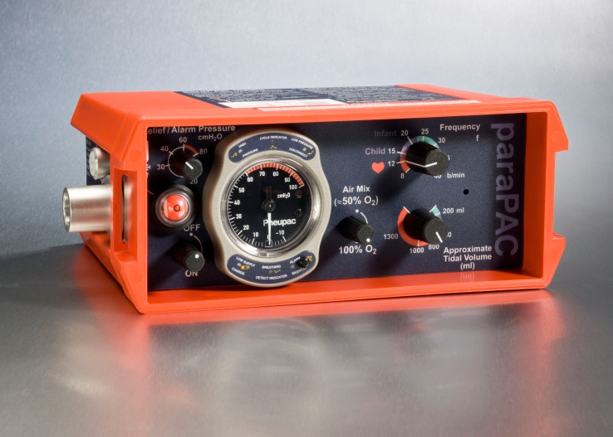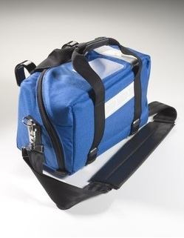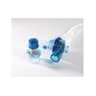 | P
- ** For any significant change in patient condition, including vital signs or oxygen saturation, or if there is a concern regarding ventilator performance or alarms, remove the ventilator from the endotracheal tube and then use a bag-valve-mask (BVM) with 100% oxygen. Contact Medical Control immediately ** | M
QA Parameters: 100% of patients where a ventilator is abandoned due to patient condition or ventilator alarm or malfunction.

