capnography

Clinical Indications
- Capnography should be used with all invasive airway procedures including endotracheal, nasotracheal, cricothyrotomy and Blind Insertion Airway Devices (BIAD) when the equipment is available to the providers involved. Capnography is a reliable and immediate indicator of adequacy of ventilation and perfusion. It may be useful in patients with cardiac disease, head injury and pulmonary disease in the absence of an invasive airway requirement.

PROCEDURE GUIDELINES
R- EMR | E – EMT | A-AEMT | P-PARAMEDIC | **M-Medical Control **
***Higher level providers are responsible for lower level treatments***
- Attach Capnography sensor to the BIAD, endotracheal tube, or oxygen delivery device.  - Note CO₂ level and waveform changes. These will be documented on each Respiratory Failure (4000), Cardiac Arrest (3000), or Respiratory Distress (4002) patient.  - The capnometer shall remain in place with the airway and be monitored throughout the prehospital care and transport.  - Any loss of CO₂ detection or waveform indicates an airway problem and should be documented, investigated and corrected.  - The capnogram should be monitored as procedures are performed to verify or correct any airway problem.  - Document the procedure and results on the PCR as well as the online Airway Evaluation.  - The following is a video demonstrating and discussing Capnography: http://paramedictv.ems1.com/media/744-Capnography-in-Emergency-Care/  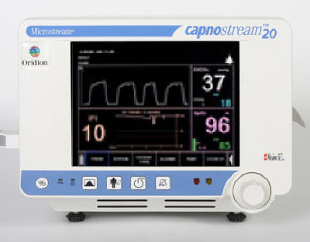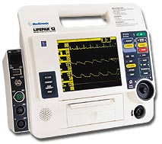 | P²³
^{2,3}EMT and AEMT providers may perform these procedures if credentialed with the appropriate OM.
ETCO2 35-45 mm Hg is the normal value for Capnography. However, some experts say 30-43 mm Hg can be considered normal.
QA Parameters: 100% of patients requiring endotracheal intubation will utilize Capnography for confirmation of tube placement.

