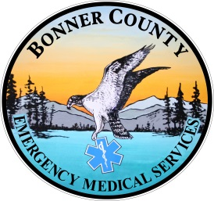
OPERATIONAL GUIDELINES
PATIENT CARE TREATMENT GUIDELINES
CLINICAL PROCEDURES AND SKILLS

Intention and Description

This manual is a compilation of guidelines used by Bonner County EMS System that describe and direct all clinical activities and delivery of EMS care within Bonner County, Idaho. These encompass 1) operational guidelines, 2) assessment and documentation guidelines, and 3) patient care treatment guidelines. We also describe the 4) procedures and skills necessary for EMS providers to assess, treat and transport patients, and the 5) medications that may be administered by our providers.

- Operational guidelines include a description of the format for patient care treatment guidelines and protocols for procedures and skills. We describe the mechanisms for on-line and off-line medical control, and describe mechanisms for appropriate scene control, scene safety and resource management as necessary for efficient and effective delivery of patient care. We describe the medico-legal issues to be considered by our providers when confronting abuse, neglect, patient refusal and death.
- Assessment and documentation guidelines describe appropriate patient contact, assessment, including vital signs, examination and documentation, including proper utilization of the patient care report (PCR).
- Patient care treatment guidelines, commonly referred to as protocols, provide clinical pathways to guide our providers in uniform and efficient assessment and management of medical, surgical and trauma patients both in adults and children. We strive to provide nationally accepted pathways using evidence based medicine, adopted for the unique characteristics of Bonner County. Protocols are organized in a manner to be useful to multiple levels of providers from First Responder (EMR) through Paramedic levels of treatment.
- We describe commonly used procedures and skills that our providers are expected to master and perform when medically necessary, and directed by patient care treatment guidelines and/or Medical Control.
- All of the medications currently available to Bonner County EMS providers are described, segregated by levels of care required to administer these drugs according to State mandated scope of practice. We also include a brief description of these medications including appropriate indications, contraindications and dosing protocols.
- Finally, it should go without saying that clinical situations will arise that will challenge any EMS provider, and not be appropriately addressed by any described protocol or guidelines. Both Off-line and On-line Medical Control can and should always be utilized for these situations.

