
Express Vinyasa Yoga Flow
8 sessions = $25 or $15 for students

Tuesdays and Thursdays
From February 26 – March 21
5:15 am – 6:00 am
Forsberg Gym, Soderstrom Elementary School, 227 N Washington.

What to expect
Move and breathe through a variety of the basic fundamental postures of yoga while learning correct alignment and use of props. Classes are designed for both students with little/no experience as well as the more experienced yogi. The style and sequence of class will vary throughout the series to best serve the students in attendance as well as the Instructors personal style.

-Bring your own mat, water, towel/blanket, or any personal prop.

-Yoga mat, block, and strap provided if you do not have any of these items. Feel free to take advantage of this service.

 Check here if you need to borrow a yoga mat.

-Please be on time and try not to leave class early in order to respect the other students in class.

-Enjoy practicing yoga at the crack of dawn with the amazing people in Lindsborg, Kansas!

Registration
Minimum class enrollment is 8 students. Please register by Monday, January 14th 2013. Registration forms can be found online through the Lindsborg Parks and Recreation website.

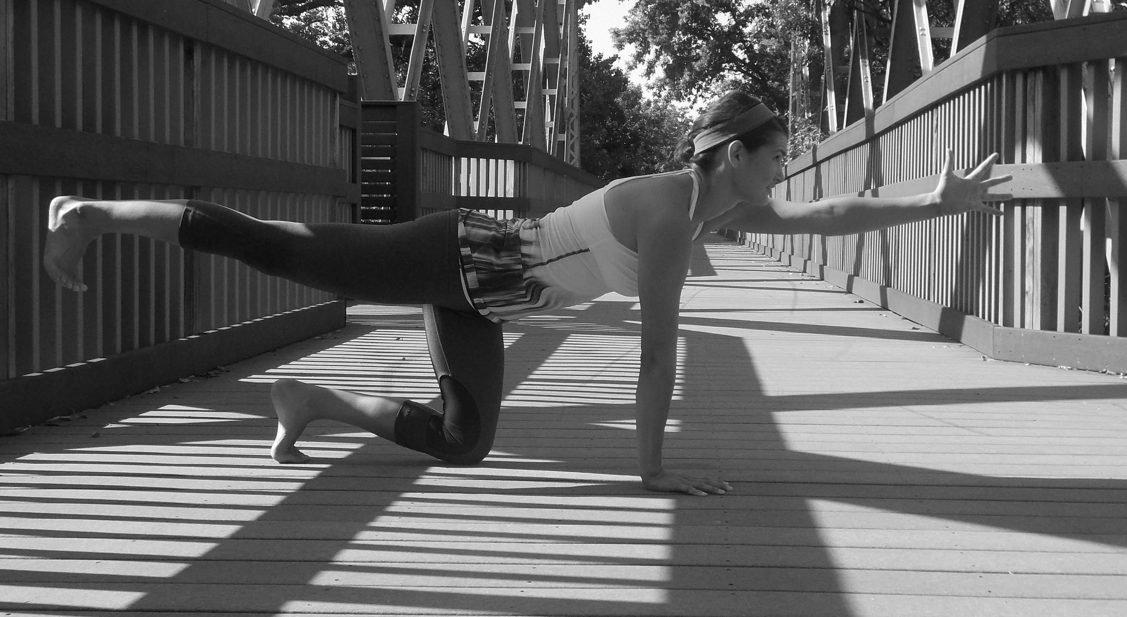

PLACE PHOTO HERE,
OTHERWISE DELETE BOX

Contact Info
• Email: Raemcmannis@gmail.com

• Cell: (707) 386-9564

• FACEBOOK Group: https://www.facebook.com/groups/195349837208585/

• List your services and products here.

• List your services and products here.

• List your services and products here.

• List your services and products here.

• List your services and products here.

About Me
After playing college soccer in 2007, Raeanna was looking to find an exercise regimen that was vigorous, yet relaxing after a long day of teaching High School Physical Education. That’s when she found yoga. It was the perfect exercise practice that met her emotional and physical needs. In 2011, Raeanna wanted to incorporate yoga into her P.E. curriculum and received a 200-hour RYS teaching certificate through Yoga Blend Studio. With 50 plus yoga mats donated to her High School program, her vision of bringing yoga to her classroom came to fruition. It was inspiring to teach and empower young people a new life-changing fitness exercise that would enhance their physical and mental health. Last year, Raeanna moved to Lindsborg, Kansas as her husband relocated to coach the girl’s college soccer team at Bethany College. She is now enjoying her new jobs as a stay at home mom and freelance yoga teacher. Raeanna is excited to share her passion for life long fitness and the amazing health benefits that yoga has to offer to all ages and fitness levels.

NAME _____________________________ADDRESS___________________________
CITY ________________________ HOME PHONE/CELL PHONE_______________

PLEASE LIST ANY MEDICAL CONDITIONS ________________________________

Email (If you would like to receive emails about programs)___________________________

Waiver Release Statement:
I, the undersigned, agree to hold harmless and indemnify the City of Lindsborg and the City of Lindsborg
Recreation Department, their employees, agents and assigns for any and all damages of personal injury claims, including third party claims, as well as all cost and fees that may be incurred arising out of or as a result of my attendance and participation in the city sponsored event, whether damage or injury is intentional or negligent, direct or indirect. I waive any rights to claims, demands, and causes of action whether present or future, known or unknown, and release from all liability the City of Lindsborg, their employees, agents and assigns. I agree to abide by all Lindsborg Recreation Department rules, regulations and accept rulings from Department staff. This waiver is also for parents to sign, who have children under 18 years of age participating in the Yoga.


SIGNATURE DATE

