Tuesdays and Thursdays
From September 17th – October 17th
No Class on October 3rd or 8th
8:00 pm – 9:00 pm
Located at Soderstrom Elementary School, 227 N. Washington

What to expect
Move and breathe through a variety of the basics and fundamental postures of yoga while learning correct alignment and the use of props. Classes are designed for both students with little/no experience as well as the more experienced yogi. The style and sequence of class will vary throughout the series to best serve the students in attendance as well as the instructor’s personal style.

-Bring your own mat, water, towel/blanket, or any personal prop.

-Yoga mat, block, and strap provided if you do not have any of these items. Feel free to take advantage of this service.

Check here if you need to borrow a yoga mat.

-Please be on time and try not to leave class early in order to respect the other students in class.

-Enjoy practicing yoga with the amazing people in Lindsborg, Kansas!

Registration
Minimum class enrollment is 8 students. Please register by Monday, September 16th 2013.

Contact Info
• Email: Raemcmannis@gmail.com

• Cell: (707) 386-9564

• FACEBOOK Group: https://www.facebook.com/groups/195349837208585/

• List your services and products here.

• List your services and products here.

• List your services and products here.

• List your services and products here.

• List your services and products here.

About Me
After playing college soccer in 2007, Raeanna was looking to find an exercise regiment that was vigorous but relaxing after a long day of teaching High School Physical Education. That’s when she found yoga. It was the perfect exercise practice that met her physical needs of being individually challenged with a playful edge. Her newfound love of yoga inspired her to bring yoga to her P.E. classroom and to pursue a 200 hour RYS teaching certificate through Yoga Blend in 2011. With 50 plus yoga mats donated to her High School program, her vision of bringing yoga to her students came to life. It was a great opportunity to learn as a new yoga instructor and an empowering experience to watch young people embrace a new life changing fitness component. Raeanna’s husband’s career as a college soccer coach plucked her out of the teaching world and into the life of as a stay at home mom and freelance yoga teacher. This new life changing role is enabling Raeanna to share her passion for life long fitness and the amazing health benefits that yoga has to offer any individual.

Express Vinyasa Yoga Flow
8 sessions $35 or $30 for students

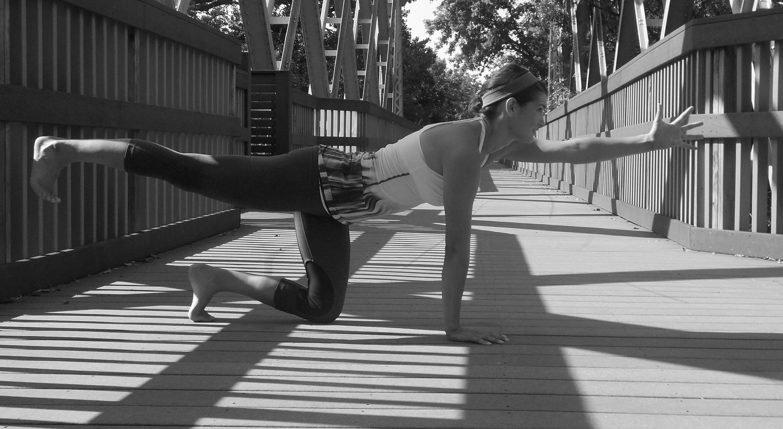

PLACE PHOTO HERE,
OTHERWISE DELETE BOX

NAME _____________________________ADDRESS___________________________
CITY ________________________ HOME PHONE/CELL PHONE_______________

PLEASE LIST ANY MEDICAL CONDITIONS ________________________________

Email (If you would like to receive emails about programs)___________________________

Waiver Release Statement:
I, the undersigned, agree to hold harmless and indemnify the City of Lindsborg and the City of Lindsborg
Recreation Department, their employees, agents and assigns for any and all damages of personal injury claims, including third party claims, as well as all cost and fees that may be incurred arising out of or as a result of my attendance and participation in the city sponsored event, whether damage or injury is intentional or negligent, direct or indirect. I waive any rights to claims, demands, and causes of action whether present or future, known or unknown, and release from all liability the City of Lindsborg, their employees, agents and assigns. I agree to abide by all Lindsborg Recreation Department rules, regulations and accept rulings from Department staff. This waiver is also for parents to sign, who have children under 18 years of age participating in the Yoga.

SIGNATURE DATE

